

VISUAL COMPUTING
IMAGE PROCESSING
Local Filtering and Historgrams
TP3

BY :- NASSIR SHAFI Ayda
RIDAOUI Hatim

12/10/2024

Overview
Image processing is essential for improving visual clarity and extracting meaningful information from images, while filtering techniques play a crucial role in enhancing image quality by reducing noise and emphasizing important features.
This project focuses on the implementation of various image filters, including a 3x3 binomial filter, a 5x5 Pascal filter, and an n-times filter to enhance image quality and reduce noise. Additionally, a median filter is applied to images such as boat_noise.pgm and boat_noise(1,2).pgm to noise while preserving edges. The outputs of each filter are analyzed and compared, highlighting their effectiveness in noise reduction and detail preservation.

Given value and pgm files used in the project
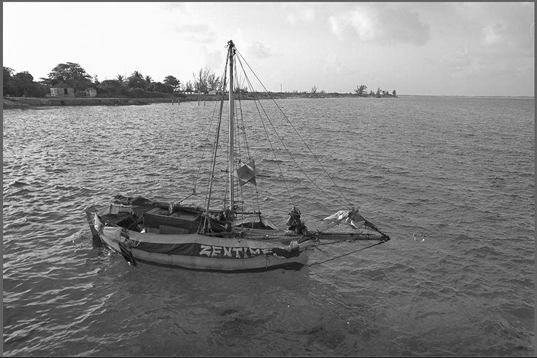
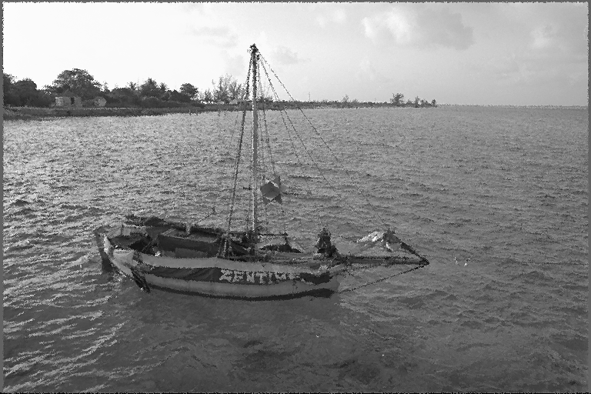

Fig 1.1 original boat.pgm without noise Fig 1.2 boat_noise1.pgm
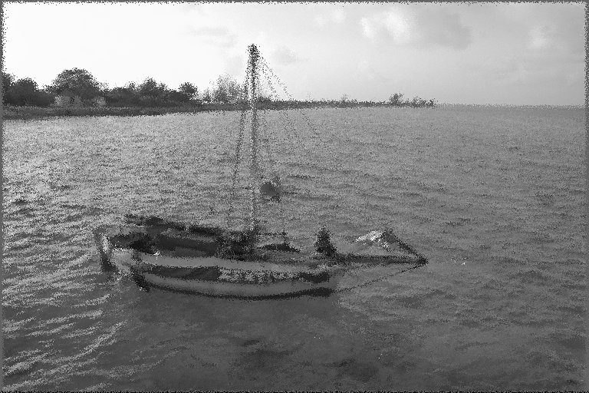

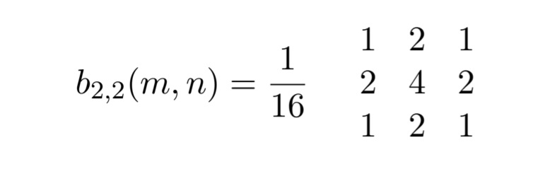

Fig 1.3 binomial filter values

Fig 1.3 boat_noise2.pgm

Exercise 1 : Filtering

Binomial filter
implementation of a 3 * 3 binomial filter

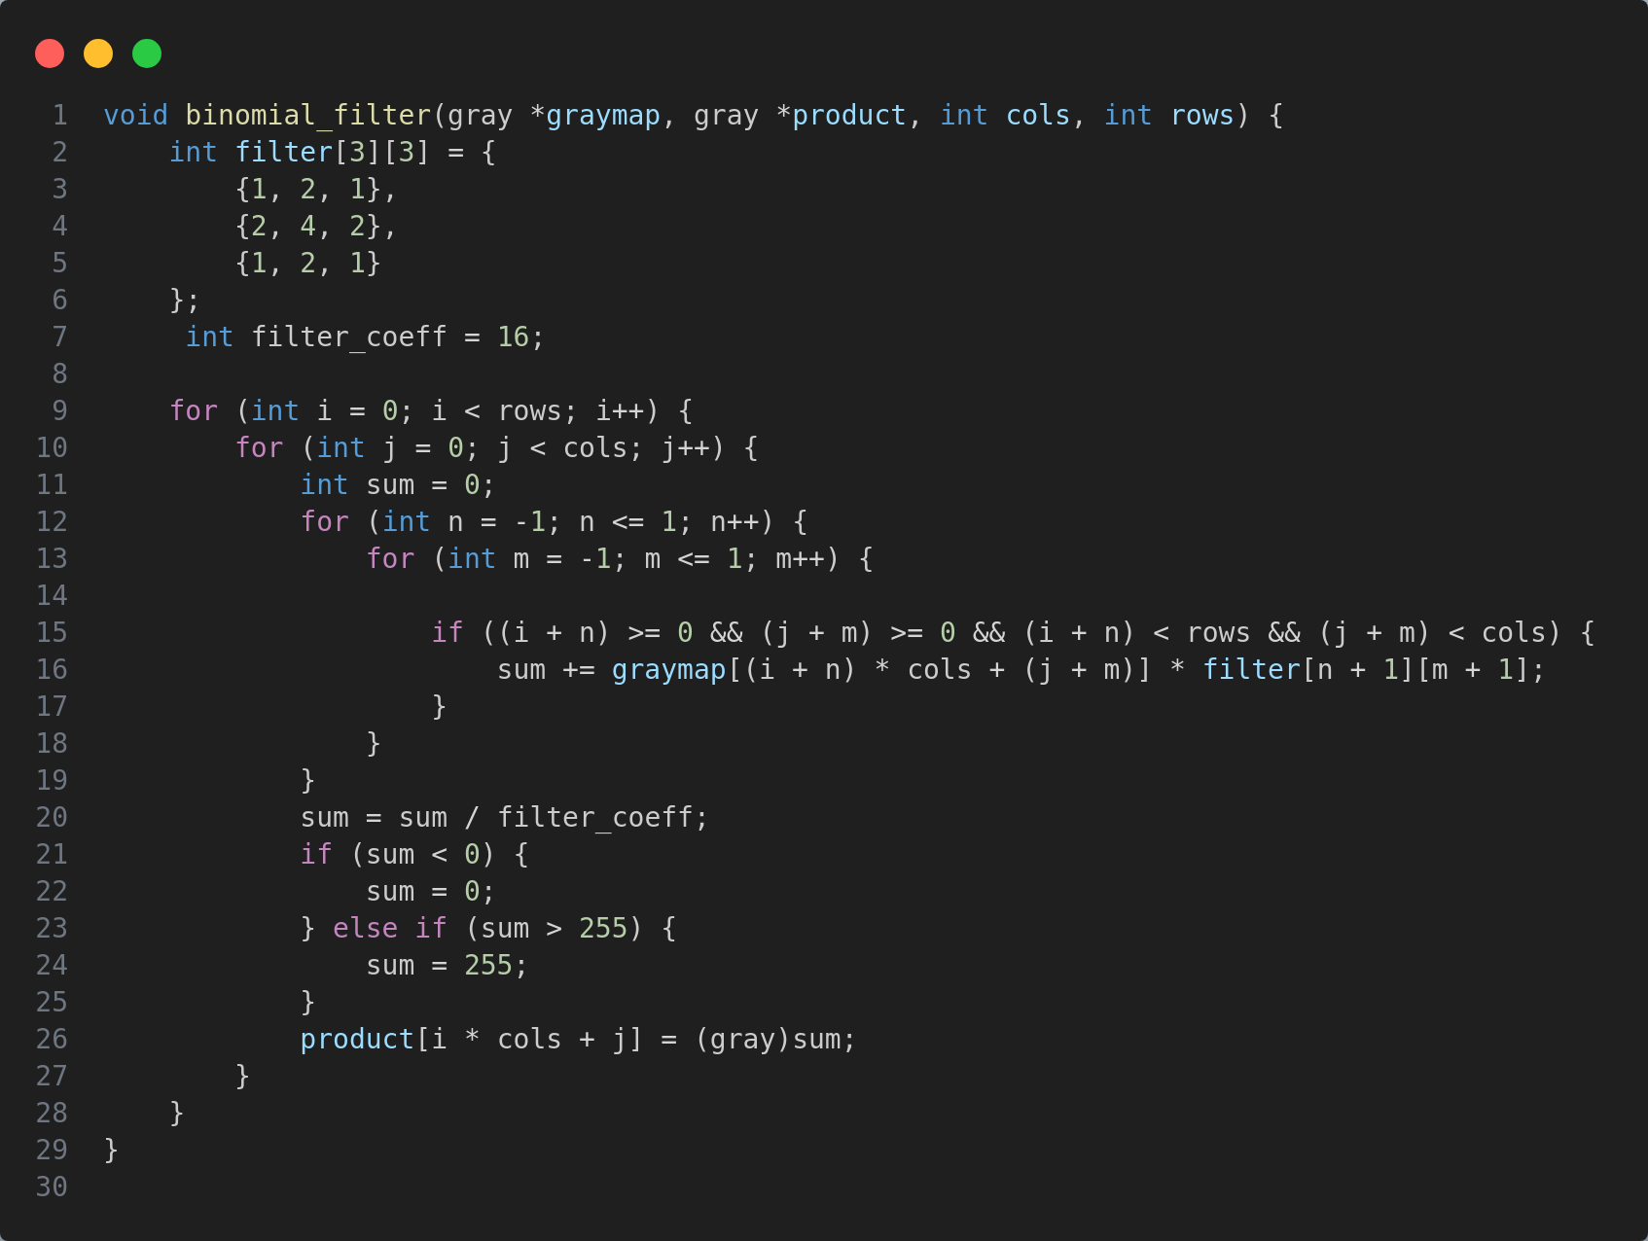
Fig 1.2 Binomial filter function

The binomial_filter function processes a grayscale image using a 3x3 binomial filter. It starts by initializing a filter matrix (which is given for the exercise) and a normalization coefficient. The function iterates over each pixel using nested loops for rows and columns. For each pixel, it initializes a sum variable to accumulate the weighted contributions from neighboring pixels. These contributions are based on the filter matrix values, applied to pixels within a 3x3 window. After calculating the weighted sum, the function normalizes the value to ensure it stays within the 0 to 255 range. Finally, the filtered value is stored in the image array product, producing the final filtered image.

Output image comparsion
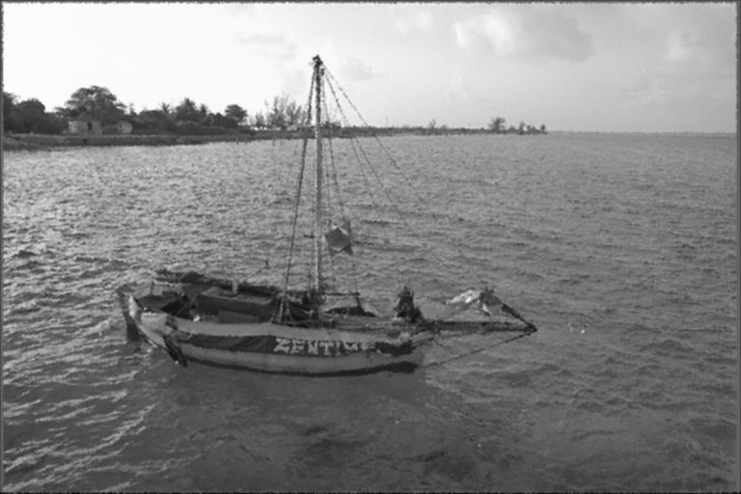

Fig boat.pgm, boat_noise1.pgm , boat_noise1_binomialfiltered.pgm in order

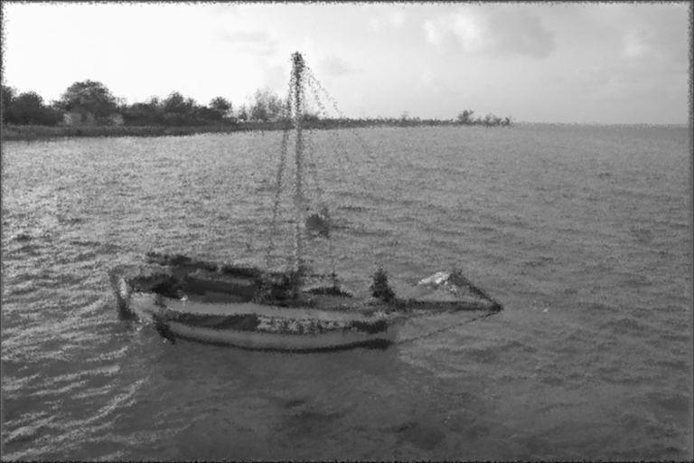
Fig boat_noise2.pgm , boat_noise2_binomialfiltered.pgm in order

